Abstract max. 400 words (Calibri 10) for text only (excluding images but including description/comment of the figure if there is any).

One page A4 maximum.

See the example below.

The European Green Deal policy ambitions set out in the Chemicals Strategy for Sustainability and the Zero Pollution Action Plan identify the transition to a Safe and Sustainable by Design (SSbD) approach to chemicals and materials. The H2020 SUNSHINE project has developed an approach to operationalize SSbD, specifically addressing multi-component nanomaterials (MCNMs), and applied it to two case studies. This approach enables assessment of safety and sustainability aspects at each stage of product development from a lifecycle perspective. This is achieved via a tiered approach that uses qualitative (Tier 1), semi-quantitative (Tier 2) and quantitative (Tier 3) assessment methods. The present work focuses on the Tier 1 (self-assessment) methodology designed to evaluate the safety, functionality and sustainability in the early R&D stages of the lifecycle of chemicals and materials. This approach was developed to be implementable by industries in a straightforward manner as often there is lack of time and/or expertise to engage in resource-intensive safety and sustainability evaluations. The approach was tested using two real industrial case studies, namely nano-enabled PFAS (Polyfluoroalkyl substances)-free anti-sticking coating for bakery molds, and nano-drops of essential oil anchored to the surface of nano clays and encapsulated in a polymeric film. The results indicate that these innovative materials have a high probability to have better safety, functionality and sustainability performance compared to conventional benchmark materials.

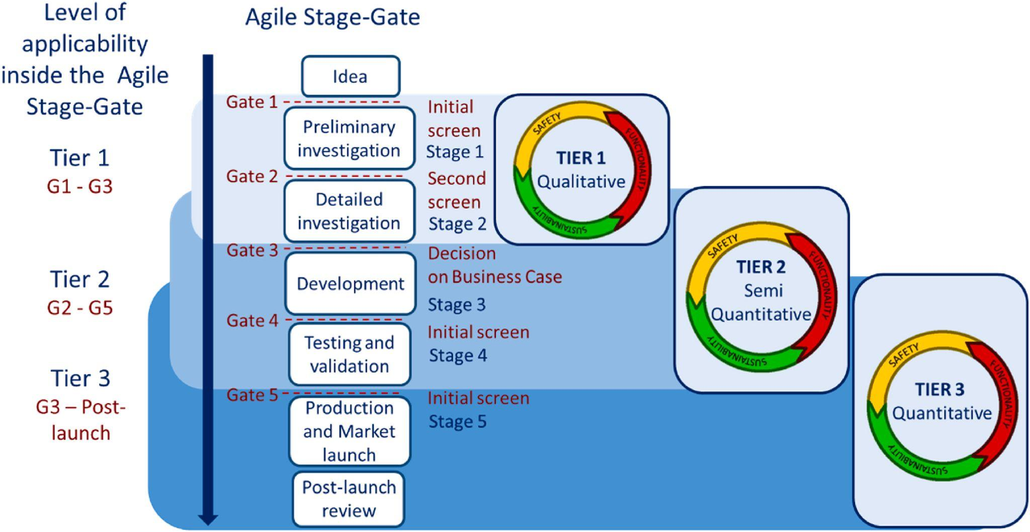

Figure: SSbD tiered assessment proposed in the SUNSHINE project. ‘Level of applicability’ means at which gate of the stage-gate the approach can be applied.

